Name: Aditya Nalini

Registration Number: 19BCE0980

Form

Code:

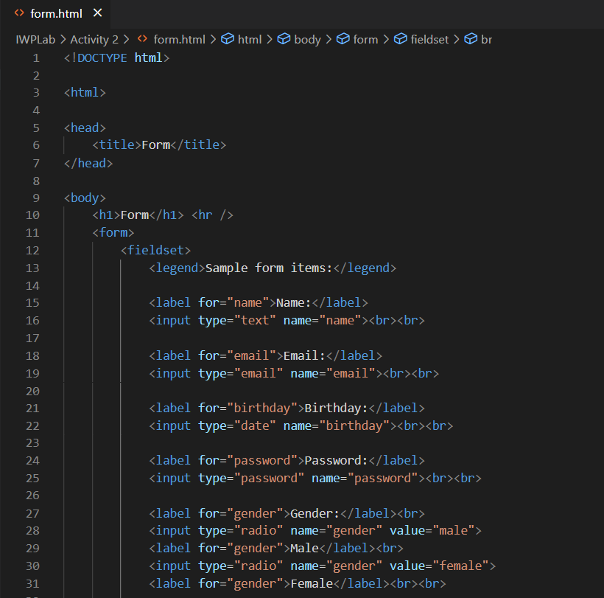

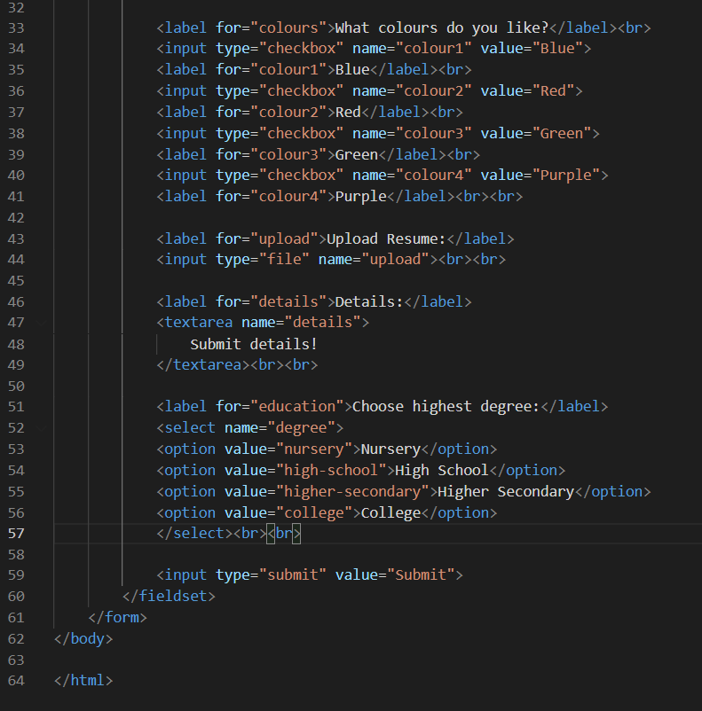

<!DOCTYPE html>

<html>

<head>

<title>Form</title>

</head>

<body>

<h1>Form</h1> <hr />

<form>

<fieldset>

<legend>Sample form items:</legend>

<label for="name">Name:</label>

<input type="text" name="name"><br><br>

<label for="email">Email:</label>

<input type="email" name="email"><br><br>

<label for="birthday">Birthday:</label>

<input type="date" name="birthday"><br><br>

<label for="password">Password:</label>

<input type="password" name="password"><br><br>

<label for="gender">Gender:</label><br>

<input type="radio" name="gender" value="male">

<label for="gender">Male</label><br>

<input type="radio" name="gender" value="female">

<label for="gender">Female</label><br><br>

<label for="colours">What colours do you like?</label><br>

<input type="checkbox" name="colour1" value="Blue">

<label for="colour1">Blue</label><br>

<input type="checkbox" name="colour2" value="Red">

<label for="colour2">Red</label><br>

<input type="checkbox" name="colour3" value="Green">

<label for="colour3">Green</label><br>

<input type="checkbox" name="colour4" value="Purple">

<label for="colour4">Purple</label><br><br>

<label for="upload">Upload Resume:</label>

<input type="file" name="upload"><br><br>

<label for="details">Details:</label>

<textarea name="details">

Submit details!

</textarea><br><br>

<label for="education">Choose highest degree:</label>

<select name="degree">

<option value="nursery">Nursery</option>

<option value="high-school">High School</option>

<option value="higher-secondary">Higher Secondary</option>

<option value="college">College</option>

</select><br><br>

<input type="submit" value="Submit">

</fieldset>

</form>

</body>

</html>

Output:

